REST

* Representational State Transfer
* Client Server Architecture



* Resource based
  + Documents
  + Images
  + Object Representations

REST has 5 Constraints

1. Client-Server Architecture
2. Layered System

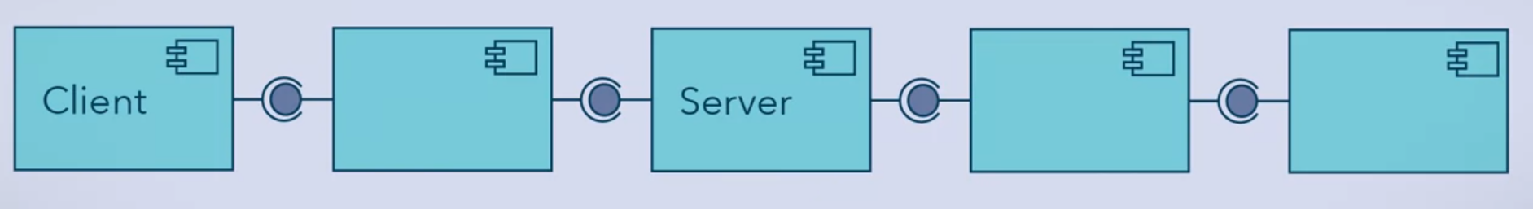

1. Stateless
   * + Each request is independent with each other
     + Server will not rely on previous requests since it does not store the previous requests



1. Cacheable
   * + Clients can keep a local copy of a server response
     + For performance improvement
2. Uniform Interface
   * + Specific methods that are understood (HTTP Methods) eg:
       - GET
       - PUT
       - POST
       - DELETE
     + Uniform Resource Identifier (URI)
     + Representations of the resources are uniform
     + Specific headers
     + 3 specific way
       - XML
       - JSON
       - Simple Text

Eg. of Request

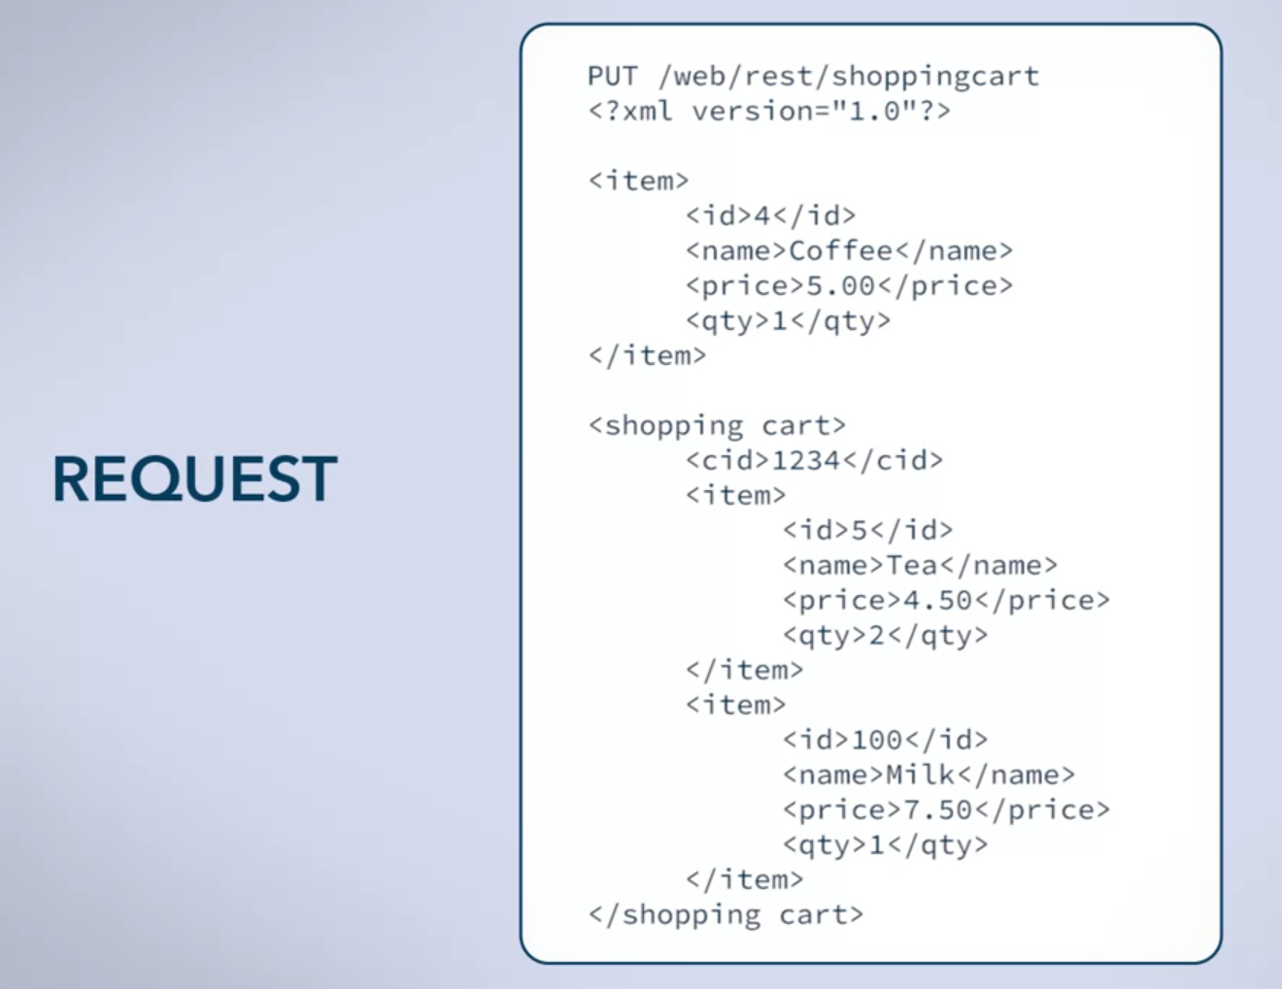

Eg. of Response

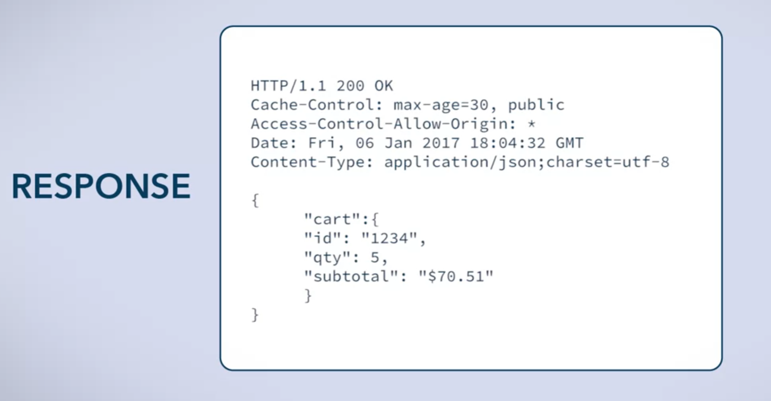

* 30 seconds max-age

Summary:

5 constraints

